The data needed to be converted from *‘1’s* and *‘0’s* to strings in the *‘hypertension’, ‘heart_disease’, and ‘diabetes’* columns. The manipulation and changing of the data were done with jupyter notebook.

The *‘hypertension’* column was labeled as *‘0’* for ‘*not hypertensive’* and *‘1’*  for ‘*hypertensive’*:

The *‘heart_disease’* column was labeled as *‘0’* for ‘*no heart disease’* and *‘1’*  for ‘*heart disease’*:

The *‘diabetes’* column was labeled as *‘0’* for ‘*not diabetic’* and *‘1’*

The resulting csv used for tableau:

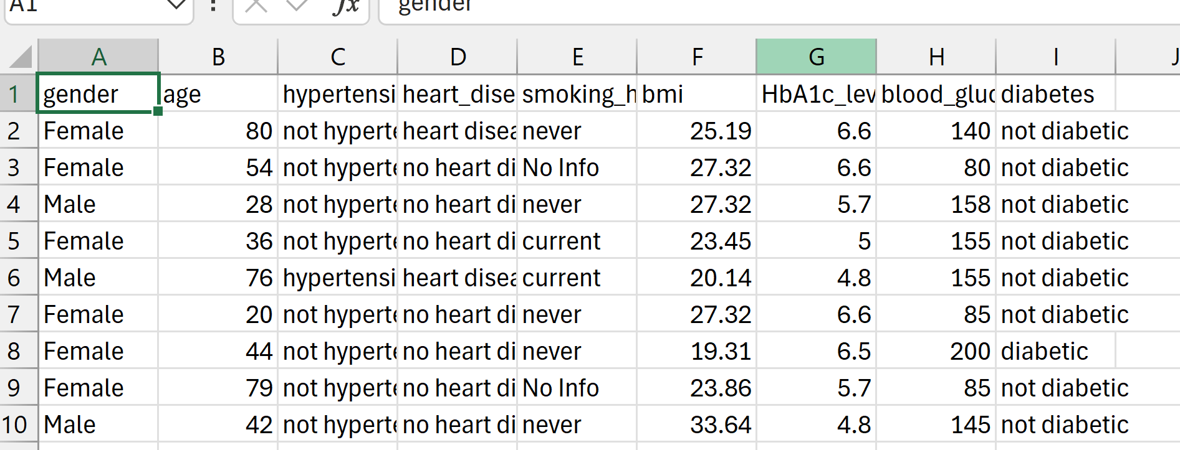

After uploading the csv, I noticed the visualizations would be easier to work with and manipulate if I created reference ranges for the *‘bmi’, ‘HbA1c_level’,* and *‘blood_glucose_level’*. The reference ranges that I used were referenced from the CDC, National Institutes of Health, and the World Health Organization.

The way I created the references in Tableau is by creating loops and ‘If’ statements:

* ‘*bmi_ranges’*:

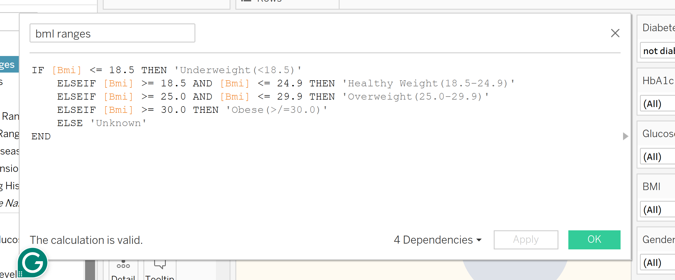

* ‘*Glucose Ranges’*:

* ‘*HbA1c Ranges’*:

